 | Qatar University  College of Engineering  Department of Computer Science and Engineering
CMPE 483 Introduction to Robotics

Course Project Report

Line-following robot design using Master Pi

Project Group Member:
Abdulla Zain (201904545)
Jassim Alansari (201912195)
Mohammad Sandouk (202007909)
Osama Aljindi (202209571)

Problem Statement
< In this project, you are required to design a simple autonomous mobile robot Master Pi kit. The main track (size 2x3 m) is shown below which was used for an internal robotics contest on May 10th 2025:
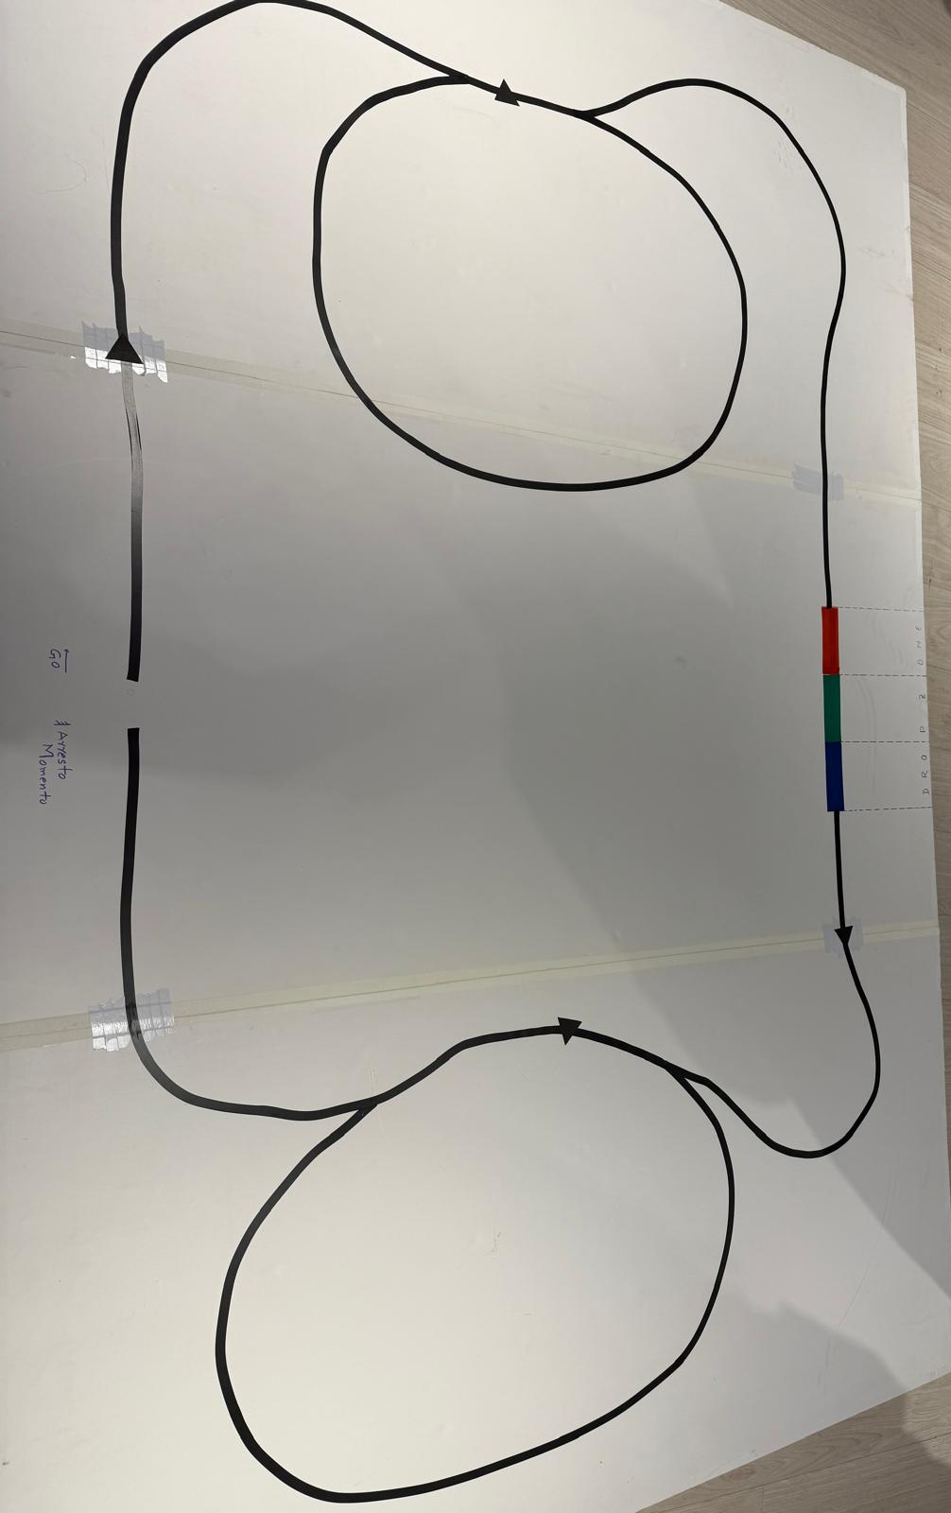
Your robot is mainly a line follower which follows a 1-inch-wide black line on a white background. In addition, the black triangle symbols on the track which indicate the decision making needed in that level of the contest as follows:
- Straight Pointing triangle: go straight and don’t get distracted by the upcoming merging lines.
- Right/Left pointing triangle: At the next bifurcation, stay on the right/left side.
The robot is shown a colored cube (Red, Green or Blue) at the start. It must detect the color and indicate it as beeps (1, 2, or 3 respectively). When the same colored section is spotted on the track, the robot must drop the cube on the left of the colored areas.

Table of Contents
Problem Statement 2
1. High Level Architecture 4
2. Design Details 5
2.1. Hardware 5
2.2. Software 6
3. Implementation 9

High Level Architecture
The architecture of our autonomous robot is built around a centralized control system running on a Raspberry Pi 5, provided as part of the MasterPi robotic kit. This kit includes an expansion board for interfacing with motors and servos, a camera, a robotic arm with a gripper, Mecanum wheels for omnidirectional movement, and ultrasonic sensors (unused in this project).
The system is structured into three core layers:
- Control Layer: At the heart of the system is a main Python script that orchestrates the robot’s behavior. This script:
  - Initializes the hardware components (motors, arm, camera, etc.),
  - Invokes the color detection routine to determine the cube’s color,
  - Launches the line-following routine for navigation,
  - Manages the drop-off logic based on color recognition and location tracking.
- Perception Layer: Once triggered by the main script, the camera captures frames which are processed using OpenCV and NumPy to detect whether the given cube is red, green, or blue. The corresponding color is stored as a reference to be matched later during the navigation task.
- Actuation Layer: The control logic drives the Mecanum wheels for movement and attempts to operate the robotic arm for cube drop-off. Motion control is achieved via MasterPi-specific libraries (e.g., common.mecanum and common.pid). Although the cube was successfully identified, the robot did not manage to correctly execute drop-off or respond to triangle-based navigation cues in the final run.
This architecture represents a top-down, centralized design, where all actions are initiated and controlled by the main script. This made debugging and sequencing more straightforward, though it limited flexibility and introduced bottlenecks in real-time decision-making. The flowchart below summarizes this architecture.
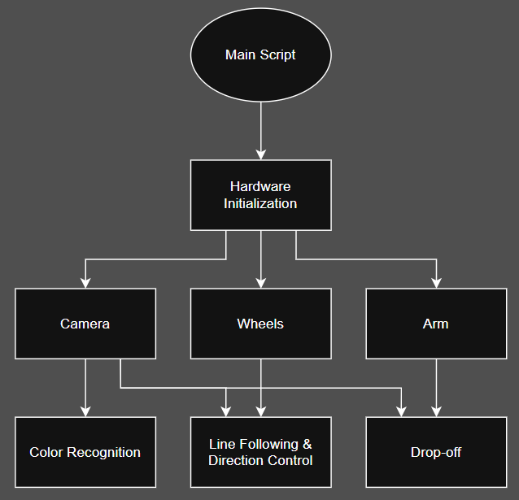

Design Details
This section outlines the detailed design specifications of the hardware and software subsystems that make up our robot system. The design aimed to satisfy the functional requirements of the project using provided hardware while managing limitations like power consumption and integration issues.

Hardware
Connectivity:
Our robot is based on the MasterPi kit, which includes an expansion board interfaced with a Raspberry Pi 5. The connectivity is summarized as follows:
- Camera → Raspberry Pi 5 via USB
- Fan → Raspberry Pi 5
- Wheel motors and arm servos → Expansion board (predefined ports)
- Expansion board ↔ Raspberry Pi GPIO (direct connection)
- Power supply → expansion board
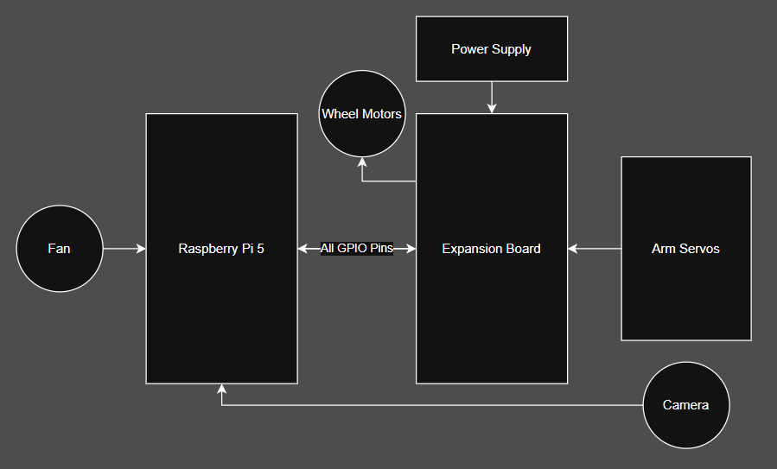
Tools and Frameworks:
- No additional hardware tools were used beyond standard assembly.
- The arm was modified slightly by attaching a paper cup with zip ties to simplify object pickup and drop-off.
- No external testing tools like multimeters or oscilloscopes were used.

Interface Approach:
- The expansion board managed all motor and servo outputs. It connected directly to the Pi’s GPIO pins internally.
- Communication between the development computer and the Raspberry Pi was done by connecting to the robot’s WiFi hotspot, which the Pi created when powered on. The Pi's desktop interface was accessed using RealVNC Viewer over this connection.

Design Justification:
The choice to use the MasterPi kit components as-is was driven by project constraints and time limitations. All control operations were implemented in software, leveraging the built-in compatibility and pre-mapped GPIO interface of the expansion board. The use of the built-in camera enabled vision processing without additional hardware customization.

Software

System Flow & Control Logic:
- Initialization Phase
  - Setup the Board and ArmIK objects
  - Inject them into the color detection and line tracking modules
- Color Detection Phase
  - Start a live camera stream
  - Wait for a color to be continuously detected for at least 1 second
  - Once confirmed, store the detected color
- Transition Delay
  - Pause for 3 seconds (to allow placing the cube)
- Line Tracking Phase
  - Start line following with PID control
  - Continue until user presses the Esc key
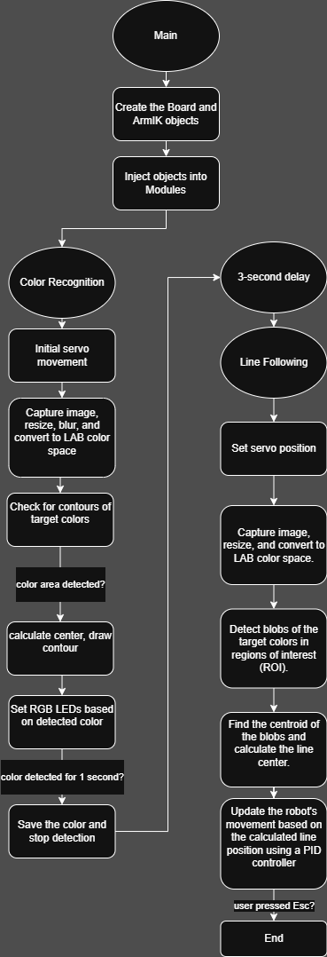
Tools & Software Used
- All scripts were written in Python, using OpenCV, numpy, threading, and other standard libraries.
- Additional project-specific modules were provided with the MasterPi, including:
common.misc, common.pid, common.mecanum, common.yaml_handle, kinematics.arm_move_ik, common.ros_robot_controller_sdk
- Scripts were initially developed on VS Code and transferred to the Pi using a USB flash drive.
- Code was executed directly via Terminal

Line Following Logic:
The line following system uses a vision-based method powered by the Raspberry Pi camera. It tracks a selected color path (in our case black, red, green, or blue) in real-time and adjusts the robot's motion to follow it accurately. The logic is implemented in the line_following.py script and includes the following core components:
- Region of Interest (ROI) Strategy:
The camera image is split into three horizontal ROIs at different vertical positions (bottom, middle, top). Each ROI is assigned a different weight (0.1, 0.3, 0.6), giving more importance to higher ROIs to anticipate upcoming turns early. This multi-ROI system improves stability and prediction compared to a single-strip approach.
- Color Detection in LAB Space:
The image within each ROI is blurred and converted to LAB color space. LAB is chosen for its better separation of luminance and chrominance, making it more robust to lighting variations. A color mask is generated using thresholds loaded from a YAML file, supporting multiple target colors.
- Centroid Calculation & Weighted Average:
The largest color blob in each ROI is detected using contours. If a valid blob is found, its bounding box is used to compute the centroid. A weighted average of centroids across ROIs is computed to determine the global line position (line_centerx), which is compared to the image center to estimate deviation.
- PID-Controlled Steering:
The deviation from the center (num = line_centerx - img_centerx) is used in a PID controller (pitch_pid) to compute an angular correction. If the deviation is small (less than ±25 pixels), PID is activated to fine-tune steering. Otherwise, the robot moves forward without adjusting the angle. The output angle directly affects the robot’s yaw (Z-axis rotation).
- Motion Execution:
The calculated velocity and rotation values are sent to the mecanum chassis controller using chassis.set_velocity(forward_speed, direction_angle, rotation_angle). If the line is lost (no valid centroid), the robot halts until the line is re-detected.
- Threaded Control Loop:
The PID-based motion logic runs in a background thread, decoupling image processing from motion control. This allows real-time performance without freezing or lag.
- Visual Feedback:
The detected contours and centroid are drawn on the frame using OpenCV for debugging and performance tuning. A yellow circle indicates the global line center used for navigation.

Implementation
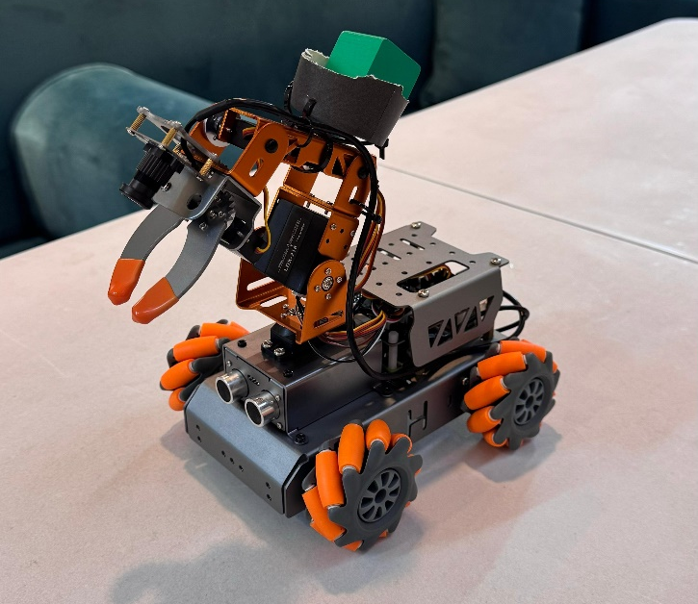

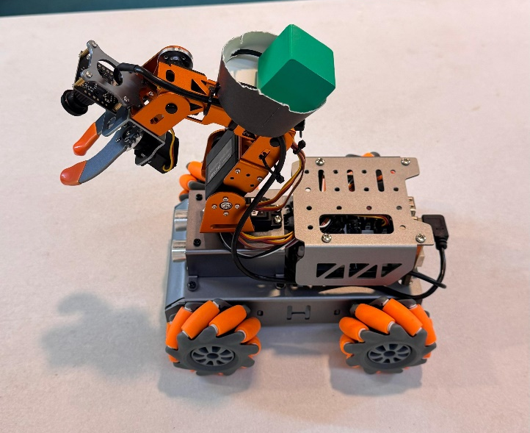

Appendix
Color Recognition:
#!/usr/bin/python3
# coding=utf8
import sys
import cv2
import time
import math
import numpy as np
import common.misc as Misc
import threading
import common.yaml_handle as yaml_handle

if sys.version_info.major == 2:
print('Please run this program with python3!')
sys.exit(0)

range_rgb = {
'red': (0, 0, 255),
'blue': (255, 0, 0),
'green': (0, 255, 0),
'black': (0, 0, 0),
'white': (255, 255, 255),
}

lab_data = None
def load_config():
global lab_data
lab_data = yaml_handle.get_yaml_data(yaml_handle.lab_file_path)

target_color = ('red', 'green', 'blue')
def setTargetColor(target_color_):
global target_color
target_color = target_color_
return (True, ())

def getAreaMaxContour(contours):
contour_area_temp = 0
contour_area_max = 0
area_max_contour = None

for c in contours:
contour_area_temp = math.fabs(cv2.contourArea(c))
if contour_area_temp > contour_area_max:
contour_area_max = contour_area_temp
if contour_area_temp > 300:
area_max_contour = c

return area_max_contour, contour_area_max

servo1 = 1500

def initMove():
board.pwm_servo_set_position(0.3, [[1, servo1]])
AK.setPitchRangeMoving((0, 5, 18), 0, -90, 90, 1500)

def set_rgb(color):
if color == "red":
board.set_rgb([[1, 255, 0, 0], [2, 255, 0, 0]])
elif color == "green":
board.set_rgb([[1, 0, 255, 0], [2, 0, 255, 0]])
elif color == "blue":
board.set_rgb([[1, 0, 0, 255], [2, 0, 0, 255]])
else:
board.set_rgb([[1, 0, 0, 0], [2, 0, 0, 0]])

color_list = []
__isRunning = False
detect_color = 'None'
saved_color = None
size = (640, 480)
interval_time = 0
draw_color = range_rgb["black"]
detection_start_time = None

def init():
print("ColorDetect Init")
load_config()
initMove()

def start():
global __isRunning
__isRunning = True
print("ColorDetect Start")

def run(img):
global interval_time, __isRunning, color_list
global detect_color, draw_color, saved_color, detection_start_time

if not __isRunning or saved_color is not None:
return img
else:
img_copy = img.copy()
img_h, img_w = img.shape[:2]

frame_resize = cv2.resize(img_copy, size, interpolation=cv2.INTER_NEAREST)
frame_gb = cv2.GaussianBlur(frame_resize, (3, 3), 3)
frame_lab = cv2.cvtColor(frame_gb, cv2.COLOR_BGR2LAB)

color_area_max = None
max_area = 0
areaMaxContour_max = 0
for i in lab_data:
if i in target_color:
frame_mask = cv2.inRange(frame_lab,
(lab_data[i]['min'][0], lab_data[i]['min'][1], lab_data[i]['min'][2]),
(lab_data[i]['max'][0], lab_data[i]['max'][1], lab_data[i]['max'][2]))
opened = cv2.morphologyEx(frame_mask, cv2.MORPH_OPEN, np.ones((3, 3), np.uint8))
closed = cv2.morphologyEx(opened, cv2.MORPH_CLOSE, np.ones((3, 3), np.uint8))
contours = cv2.findContours(closed, cv2.RETR_EXTERNAL, cv2.CHAIN_APPROX_NONE)[-2]
areaMaxContour, area_max = getAreaMaxContour(contours)
if areaMaxContour is not None:
if area_max > max_area:
max_area = area_max
color_area_max = i
areaMaxContour_max = areaMaxContour

if max_area > 2500:
rect = cv2.minAreaRect(areaMaxContour_max)
box = np.intp(cv2.boxPoints(rect))
cv2.drawContours(img, [box], -1, range_rgb[color_area_max], 2)

(center_x, center_y), radius = cv2.minEnclosingCircle(areaMaxContour_max)
center_x = int(Misc.map(center_x, 0, size[0], 0, img_w))
center_y = int(Misc.map(center_y, 0, size[1], 0, img_h))
cv2.putText(img, 'X:'+str(center_x)+' Y:'+str(center_y), (center_x-65, center_y+100),
cv2.FONT_HERSHEY_SIMPLEX, 0.65, draw_color, 2)

if color_area_max == 'red':
color = 'red'
elif color_area_max == 'green':
color = 'green'
elif color_area_max == 'blue':
color = 'blue'
else:
color = None

if color == detect_color:
if detection_start_time and (time.time() - detection_start_time >= 1.0):
saved_color = color
__isRunning = False
elif detection_start_time is None:
detection_start_time = time.time()
else:
detection_start_time = time.time()

detect_color = color
draw_color = range_rgb.get(color, range_rgb["black"])
else:
draw_color = (0, 0, 0)
detect_color = "None"
detection_start_time = None

set_rgb(detect_color)
return img

if __name__ == '__main__':
from kinematics.arm_move_ik import *
from common.ros_robot_controller_sdk import Board
board = Board()
AK = ArmIK()
AK.board = board

init()
start()
cap = cv2.VideoCapture('http://127.0.0.1:8080?action=stream')
while True:
ret, img = cap.read()
if ret:
frame = img.copy()
Frame = run(frame)
frame_resize = cv2.resize(Frame, (320, 240))
cv2.imshow('frame', frame_resize)
key = cv2.waitKey(1)
if key == 27:
break
else:
time.sleep(0.01)
cap.release()
cv2.destroyAllWindows()

Line Following:
import sys
sys.path.append('/home/pi/MasterPi/')
import cv2
import time
import math
import signal
import Camera
import threading
import numpy as np
import common.pid as PID
import common.misc as Misc
import common.yaml_handle as yaml_handle
import common.mecanum as mecanum
from kinematics.transform import *

chassis = mecanum.MecanumChassis()
pitch_pid = PID.PID(P=0.0009, I=0.000002, D=0.0003)

range_rgb = {
'red': (0, 0, 255),
'blue': (255, 0, 0),
'green': (0, 255, 0),
'black': (0, 0, 0),
'white': (255, 255, 255),
}
if sys.version_info.major == 2:
print('Please run this program with python3!')
sys.exit(0)

def setTargetColor(target_color):
global __target_color
__target_color = target_color
return (True, ())

lab_data = None

def load_config():
global lab_data
lab_data = yaml_handle.get_yaml_data(yaml_handle.lab_file_path)

def initMove():
board.pwm_servo_set_position(0.8, [[1,2500],[3,500],[4,2500],[5,1261],[6,1500]])
chassis.set_velocity(0,90,0)

line_centerx = -1

def reset():
global line_centerx
global __target_color
line_centerx = -1
__target_color = ()

def init():
load_config()
initMove()

__isRunning = False

def start():
global __isRunning
reset()
__isRunning = True

def stop():
global __isRunning
__isRunning = False
chassis.set_velocity(0,90,0)

def exit():
global __isRunning
__isRunning = False
chassis.set_velocity(0,90,0)

def getAreaMaxContour(contours):
contour_area_max = 0
area_max_contour = None
for c in contours:
contour_area_temp = math.fabs(cv2.contourArea(c))
if contour_area_temp > contour_area_max:
contour_area_max = contour_area_temp
if contour_area_temp >= 5:
area_max_contour = c
return area_max_contour, contour_area_max

img_centerx = 320
line_centerx = -1

def move():
global line_centerx
while True:
if __isRunning:
if line_centerx > 0:
num = line_centerx - img_centerx
if abs(num) < 25:
pitch_pid.SetPoint = num
else:
pitch_pid.SetPoint = 0
pitch_pid.update(num)
angle = pitch_pid.output
chassis.set_velocity(25, 90, -angle)
time.sleep(0.1)
else:
chassis.set_velocity(0, 90, 0)
time.sleep(0.2)
else:
time.sleep(0.01)

th = threading.Thread(target=move)
th.daemon = True
th.start()

roi = [
(240, 280, 0, 640, 0.1),
(340, 380, 0, 640, 0.3),
(430, 460, 0, 640, 0.6)
]

roi_h1 = roi[0][0]
roi_h2 = roi[1][0] - roi[0][0]
roi_h3 = roi[2][0] - roi[1][0]
roi_h_list = [roi_h1, roi_h2, roi_h3]
size = (640, 480)

def run(img):
global line_centerx
global __target_color

img_copy = img.copy()
img_h, img_w = img.shape[:2]

if not __isRunning or __target_color == ():
return img

frame_resize = cv2.resize(img_copy, size, interpolation=cv2.INTER_NEAREST)
frame_gb = cv2.GaussianBlur(frame_resize, (3, 3), 3)
centroid_x_sum = 0
weight_sum = 0
center_ = []
n = 0

for r in roi:
roi_h = roi_h_list[n]
n += 1
blobs = frame_gb[r[0]:r[1], r[2]:r[3]]
frame_lab = cv2.cvtColor(blobs, cv2.COLOR_BGR2LAB)
frame_mask_total = np.zeros((blobs.shape[0], blobs.shape[1]), dtype=np.uint8)

for i in __target_color:
if i in lab_data:
mask = cv2.inRange(frame_lab, tuple(lab_data[i]['min']), tuple(lab_data[i]['max']))
frame_mask_total = cv2.bitwise_or(frame_mask_total, mask)

eroded = cv2.erode(frame_mask_total, cv2.getStructuringElement(cv2.MORPH_RECT, (3, 3)))
dilated = cv2.dilate(eroded, cv2.getStructuringElement(cv2.MORPH_RECT, (3, 3)))
cnts = cv2.findContours(dilated, cv2.RETR_EXTERNAL, cv2.CHAIN_APPROX_TC89_L1)[-2]
cnt_large, area = getAreaMaxContour(cnts)

if cnt_large is not None:
rect = cv2.minAreaRect(cnt_large)
box = np.intp(cv2.boxPoints(rect))
for i in range(4):
box[i, 1] = box[i, 1] + (n - 1) * roi_h + roi[0][0]
box[i, 1] = int(Misc.map(box[i, 1], 0, size[1], 0, img_h))
for i in range(4):
box[i, 0] = int(Misc.map(box[i, 0], 0, size[0], 0, img_w))
cv2.drawContours(img, [box], -1, (0, 0, 255, 255), 2)
pt1_x, pt1_y = box[0, 0], box[0, 1]
pt3_x, pt3_y = box[2, 0], box[2, 1]
center_x, center_y = (pt1_x + pt3_x) / 2, (pt1_y + pt3_y) / 2
cv2.circle(img, (int(center_x), int(center_y)), 5, (0, 0, 255), -1)
center_.append([center_x, center_y])
centroid_x_sum += center_x * r[4]
weight_sum += r[4]

if weight_sum != 0:
line_centerx = int(centroid_x_sum / weight_sum)
cv2.circle(img, (line_centerx, int(center_y)), 10, (0, 255, 255), -1)
else:
line_centerx = -1
return img

def Stop(signum, frame):
global __isRunning
__isRunning = False
chassis.set_velocity(0, 90, 0)

if __name__ == '__main__':
from kinematics.arm_move_ik import *
from common.ros_robot_controller_sdk import Board
board = Board()
AK = ArmIK()
AK.board = board

init()
start()
signal.signal(signal.SIGINT, Stop)
cap = cv2.VideoCapture('http://127.0.0.1:8080?action=stream')
__target_color = ('black', 'red')
while __isRunning:
ret, img = cap.read()
if ret:
frame = img.copy()
Frame = run(frame)
frame_resize = cv2.resize(Frame, (320, 240))
cv2.imshow('frame', frame_resize)
key = cv2.waitKey(1)
if key == 27:
break
else:
time.sleep(0.01)
cv2.destroyAllWindows()

Main:
import time
import cv2

import color1
import LineTracking1 as lt

from common.ros_robot_controller_sdk import Board
from kinematics.arm_move_ik import ArmIK

def main():
# 1) Hardware setup
board = Board()
ak = ArmIK()
ak.board = board

# 2) Inject into modules
color1.board = board
color1.AK = ak
lt.board = board
lt.AK = ak

# === COLOR DETECTION ===
color1.init()
color1.start()

cap = cv2.VideoCapture('http://127.0.0.1:8080?action=stream')
while True:
ret, frame = cap.read()
if not ret:
time.sleep(0.01)
continue

out = color1.run(frame)
cv2.imshow('Color Detect', cv2.resize(out, (320,240)))

if cv2.waitKey(1) & 0xFF == 27:
break
if color1.saved_color is not None:
print(f"→ Saved color: {color1.saved_color}")
break

cap.release()
cv2.destroyAllWindows()

# 3-second “short delay”
time.sleep(3)

# === LINE TRACKING ===
lt.init()
lt.setTargetColor(('red','green','blue','black')) # follow any line color
lt.start()

cap = cv2.VideoCapture('http://127.0.0.1:8080?action=stream')
while True:
ret, frame = cap.read()
if not ret:
time.sleep(0.01)
continue

out = lt.run(frame)
cv2.imshow('Line Track', cv2.resize(out, (320,240)))

if cv2.waitKey(1) & 0xFF == 27:
lt.stop()
break

cap.release()
cv2.destroyAllWindows()

if __name__ == '__main__':
main()

